For the teacher:

Activity 1: Give the students a bag of random household goods/lab equipment/ stationary etc and ask them to classify the goods into groups.

Get them to explain to the class how they did it.

You can get them to try as many ways as possible.

After second worksheet.

Activity 2: Give each student 6 different lollies (Minties, Fantales, Clinkers, Marshmallow, Jaffas and Bon Bons).

Place them on a piece of A3 paper and get them to start to make a dichotomous key to classify them.

Activity 3: Use the “Fishy Features” page to make a dichotomous key for the marine species listed.

Activity 4: Hand the students a copy of the ‘Fish Dichotomous Key’. Show them one fish at a time and ask them to identify them from the key.

When classifying organisms, taxonomists use the following framework:

Kingdom ____________
Phylum _____________
Class ______________
Order _____________
Family ____________
Genus ____________
Species ___________

Classification makes it easier to identify, describe and remember species. Since there are thousands of organisms described from Australia alone, and more new species are being discovered every year, the use of an international classification system is extremely important.

1. What does classification mean? ______________________________________

2. Why do we classify organisms? ______________________________________

________________________________________________________________

Classification is used for the scientific naming, identifying and describing of individuals, and determining relationships between groups and their evolutionary links.

3. What does evolutionary links mean? ___________________________________

_________________________________________________________________

Scientific names are internationally recognised names given to living things. Scientific names are always written in italics, with the genus name first, followed by the species name, e.g., Plectropomus leopardus is the scientific name for coral trout.

4. What is your scientific name? ________________________________________

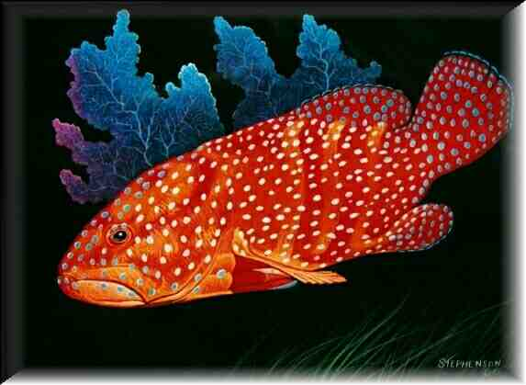
Coral Trout

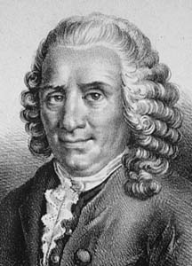

Taxonomists are scientists who classify and name plants and animals.

A Swedish botanist in 1753 by the name of Carolus Linnaeus devised a two-name system that we now know as binominal nomenclature. The first name is the organism’s generic name or genus. This is also used in the name of closely related organisms. The second name is the organism’s specific name or species.

1. What does the prefix ‘bi’ mean? (think bicycle, how many wheels?) __________

2. How many names in the binominal nomenclature system? __________________

A dichotomous key is a method for identifying something by going through a series of choices leading to the correct answer. Dichotomous means divided into 2 parts. At each step, there are two choices, with each answer leading to another question with a further 2 choices until the item is identified.
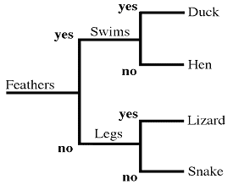

Dichotomous Key

3. What does dichotomous mean?

______________________________

______________________________

When making a dichotomous key:

- Use constant characteristics rather than variable ones. Variable means __________
- Use measurements rather than terms like ‘large’ and ‘small’.
- Use characteristics that are generally available to the user of the key rather than
seasonal characteristics.
- Make the choice positive – something ‘is’ instead of ‘is not’.
- Precede descriptive terms with the name of the part to which they apply.

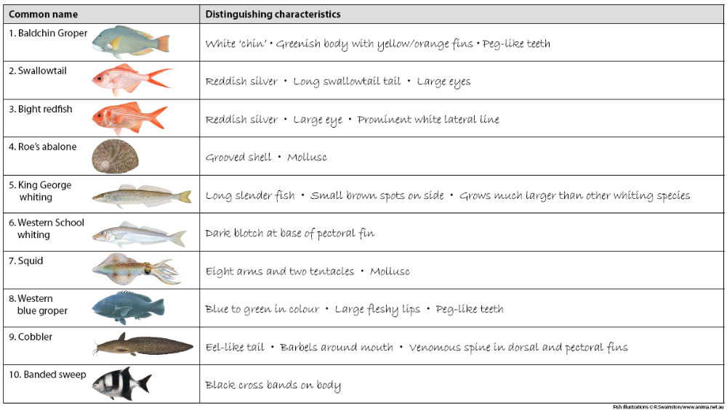
Fishy Features



